19 MAY 20210_Comments from EMAN Conference
-You discuss the idea that this paper is related with open systems in which knowledge of others in incorporated, but I do not understand how you do it
I see your system only capture the production view, so how do you consider the points of view of others?
-In general the paper “touch” too many concepts (non-human agency, etc.), but it do not go in detail…neither in the text neither in the figures…. Please, try to introduce in the paper only the really “necessary concepts”
- Movement building is very broad…. I not convince you do an appropriate link between movement building and your model (they do not know Latour). They propose us to use agency theory

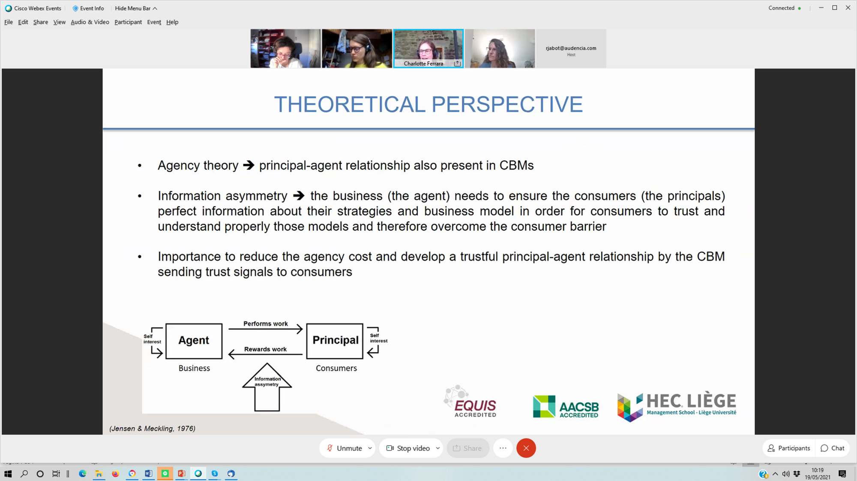

-Literature….you touch a very broad literature, I suggest you only “touch” the necessary ideas, see Alvesson and Sandberg (2020) paper in order to review literature
-In the figure of the model, the directions of narrow is clear explained
-They think that an important contribution is to show consumers other business models, make the model accessible to them.

