A circularity accounting model: dis-hoping using neural networks for the operationalization of circular economy

Forrest Fabian Jesse^{a b}, Carla Antonini^{c}, Mercedes Luque-Vilchez^{d}

ªUniversity of Washington, DXARTS, Seattle, WA, 98195-1570, United States
^{b}Beijing Xixuan Laboratory, Beijing, 100044, China
^{c}Autonomous University of Madrid, Department of Accounting, Madrid, 28049, Spain
^{d}University of Córdoba, Dpt. Agric. Economics, Sociology, and Policy, Córdoba, 14071, Spain

^{c} Corresponding author: Carla Antonini. Departamento de Contabilidad. Universidad Autónoma de Madrid. Fco Tomás y Valiente 5, 28049 Madrid (SPAIN). Tel. +34 91 497 6070. E-mail: carla.antonini@uam.es

A circularity accounting model: dis-hoping using neural networks for the operationalization of circular economy

Abstract
Purpose – The paper discusses critically that circular economy cannot be operationalized applying current dominant managerial paradigms and traditional accounting in financial terms and reflects on how accounting develops a pivotal role in operationalization of a circular economy, proposing the development of a circularity accounting model that takes into account planetary boundaries and individual decision-making.
Design/methodology/approach – Drawing on the movement building approach, this paper enquires methodologically into the applicability of neural networks in the development of a carbon estimator useful for circularity accounting. The estimator uses neural networks to accomplish a re-assessment of the use of carbon across global supply chains.
Findings – Circularity accounting has the potential to enable the operationalization of circular economy in the search for a more sustainable use of natural resources by portraying a method of prediction of the carbon contribution for a certain object across the entire supply, consumption, and disposal chain.
Limitations – The analysis is limited at this stage at an operative level. Some parts of the software system of the estimator portrayed in this research are still untested.
Contribution – The study provides two contributions to previous literature. (i) It proposes a cross-disciplinary collaboration exploring the application of movement building and neural networks in the development of a circularity accounting model. (ii) It enquires methodologically into the application of neural networks to develop a carbon dioxide estimator that uses carbon dioxide instead of monetary units as a unit of measure, exposing the use of natural resources otherwise hidden in monetary terms.
Keywords: circular economy; climate change; neural networks; movement building, sustainability accounting.
Paper type: Original research

1. Introduction

In a separate file
Structure of the rest of the paper: 2) Theoretical framework, 3) Model & Arquitecture of CAM (including carbon estimator), 4) Example of Yakoult case study, 5) Concluding remarks and conclusion.

2. Theoretical framework
In a separate file

Section. 3. CAM: Model & Architecture

Based on ideas exposed in section 2, this research proposes an accounting model that provides information to individuals with the aim of empowering collective agency: the circularity accounting model (CAM). This individual accounting model aims to operationalize circular economy transforming accounting into a tool aware and respectful with the planetary boundary of climate change (Rockström et al, 2009).
CAM shifts, at least, below accounting rules of measurement and valuation: (i) capital to maintain: it shifts from financial capital to natural capital within the framework of planetary boundaries, particularly the boundary of climate change. The model acknowledges the existence of entropy. Entropy production accompanies life, and human life produces current economies. Within the realm of present technology and planetary boundaries, the limits of CO2 limit economic activity and production of physical products and transportation. The consolidation of energy toward a goal is a process that attracts the attention of economic planners, its symmetric opposite, the divestiture of entropy, is of concern not only of economic planners but also of living creatures. Divestiture of entropy outward is of concern in closed systems (as gas pressure for example). This is as apparent when entropy production is encumbered by a container (PV=nRT, for example), as when economic growth approaches planetary boundaries (a more complex relationship). In the present paper, we may consider entropy production as it is embedded in the production of planetary CO2. Acknowledgment of planetary boundaries as a boundary on entropy production and the assertion that humans cannot exercise economic activity beyond natural limits results in CAM shifting to the maintenance of natural capital as opposed to the focus on economic capital in traditional accounting.
(ii) accounting entity: it shifts from financial control to sustainability control (Antonini & Larrinaga, 2017) along the global supply chain incorporating definitions of entity boundaries, and may thereby improve resolution of responsibility. More clarification NEEDED?
(iii) units of measure: it shifts from monetary units to physical units (CO2) using an estimator based in neural networks. CAM argues that enlarging the boundaries of producers’ reporting to align the disclosure of information with the responsibility over the whole supply chain affected (Antonini & Larrinaga, 2017; Archel et al., 2008) is not sufficient. It is also necessary to connect the economic value of transforming products along the whole supply chain to a physical value. CAM may resist the expansion of market rules to the environment (O´Neill, 2007). In the endeavour to develop CAM as a means for change, it is necessary to reconnect the transmission of data and information with the physical objects that they proxy, instead of valuing all economics according to the market rules and in monetary units. Ultimately, it may be useful to align accounting with quantification of pollution, climate change and biodiversity loss among other planetary boundaries limiting conditions for human development (Rockström et al., 2009). If the accounting framework needs to disclose the value of real flows of good and services, therefore, the measuring system needs to be founded on real (physical) flows of goods and services and not merely on the financial-monetary reflection of it. The planetary boundaries offer the justification to expose the real flow and reflect the physical limitations of the economy and the environment.

Figure 2 discloses the CAM developed in this paper. The CAM measures direct and indirect CO2 emissions of products in a supply-disposal chain with the goal of reducing emissions and increasing awareness of stakeholders. The circle at the centre of the figure represents one full cycle of the supply-disposal chain for one product. The geometric circle is the ideal to be achieved. If a product supply chain moves within a circle, it will end to restart a new cycle with zero lost CO2. Variance from circularity is a measure of entropy introduced to carbon sequestration (carbon accounting chain entropy, S_{chain}), which can decrease or increase at each step in the path of production-consumption-disposal.

FIGURE 2 aprox here

Products’ carbon accounting chains are plotted against the circle and variance from circularity shows the entropy profile of a chain S_{chain}. Point A in Figure 3 represents the beginning of the supply chain, where the emissions of CO2 are still zero. Point B represents the right half of the cycle where the production and transportation phases end. This can be described as the “production phases”, this point in the circle represents all the additions needed along the supply chain to make the final product available for consumers. Point C represents the point where the supply chain ends. Between point B and C are included all the phases of consumption and waste management. It could be described as the “consumption-disposal phases”. Points A1, A2, etc. represent the different stages within the production phases, where points B1, B2, etc. represent the different stages within the destruction phases. Positions in the supply-disposal chain are unlikely to match the inner ideal circle and each product will have a different shape. For example, in the case of B5 and B7 it is noticeable that both are far away from the inner circle. The journey in the supply-disposal chain from beginning to end on the circle is a translation though resource configuration space, movement on the circle represents the re-ordering of the resource network.

3.1 Tools/Steps? to implement CAM: Architecture/steps/tools?

The CAM is implemented in three steps using neural networks:
- a method and system called a ‘carbon estimator’ which can detect recognize and classify objects and to calculate their carbon sequestration.
- (ii) A library of components of the objects so that the costs and implications of the objects is available.
- (iii) A method of prediction of carbon chain, showing the carbon contributions for an object.
@Jesse: Is this part of the architecture?
Carla Antonini Morales
Jesse: 1) what is the difference between the carbon estimator and the method of prediction???!! For me they are the same thing. Can you please clarify?

“method of prediction of carbon chain” not “method of prediction”. i the ‘carbon estimator’ is a method of prediction for objects. iii ‘A method of prediction of carbon chain’ is for carbon chains, supply-disposal chains.

2) Do we need this clarification (if so add as a footnote or clarification somewhere) or delete?--> “Referring to carbon in the context of the estimator we mean the CO2 equivalent sequestered in an object”.

needs clarification if reader doesn’t understand. Lets ask questions and insert the replys in the paper

Figure 3 shows the ARCHITECTURE of the model (PENDENT FIGURE)

sure. the architecture is the same figure with variables substituted for the Yakoult product.

Explanation of figure 3 (ONLY THE ARCHITECTURE// NO Yakoult example)

3.1.1 Carbon estimator
In the development of the carbon estimator, this paper undertakes an investigation into defining objects as an encoding in a neural network, so that a network identifies objects and contains the definitive model of the object. For example, what is milk: a network recognizes milk from data, and so ‘milk’ is detected as present when the neural network detects it. Whether the milk is a bottle, or in a bottle, a box, a droplet, or cow these are details which the neural network detector must manage. Employing neural network detectors for the definition of economic objects is in comparison to previous definitions of such objects, in which they are defined in terms of language, and by the work of human agency where a person physically acts on an object, or by a social and legal framework that is enforced by human agency. The CO2 estimator models the ‘CO2 of things’ acting to classify from observer independent definitions of objects which do not require the continuous intervention of human or social agency.
Neural networks which can successfully detect, recognize, and describe real world objects, locations and features are called models, they model a neural network processor. The successful process will result in the detection or recognition of objects or features, from incoming data.

We develop a carbon cost estimator. The estimator is a software tool, which takes sensor input data, and processes it though a neural network, the result is a classification of the object found in the data, into a category, which describes its carbon content. The category is retrieved from a database that lists all known objects, and each object is recognizable by a neural network which has been trained to recognize the object from visual data.

Objects to be analysed are in general sensed through video that is broken into images, each of which is treated as a multidimensional surface of data mapped to a matrix. Each matrix cell might contain colour, intensity, frequency, spatial position, or other characteristics.
right. will move this.
An object is not assumed to be a mass which exists, but is a set of data for which an agenda for investigation is followed in an architecture of detectors and classifiers, and finally a specialized recognizer. Popular model architectures in the last decade have been those trained on imagenet (Deng et al., 2010) which classifies incoming images, single-shot-detector (Liu et al., 2016) which detects objects in incoming images, and autoencoders (Sundermeyer et al., 2019; Nourmohammadi-Khiarak et al., 2018; Li et al., 2019) which can recognize the visual details of objects.

The present estimator performs carbon sequestration estimation using (deep) neural network models and is a process of: (i) building and training models of economic objects (products), (ii) obtaining their CO2 sequestration value from existing reports, and (iii) connecting models together. The first two items in this process require the participation of people to acquire samples of data (visual images, photos or video in the simplest case) from the object that is to be estimated, and to assign CO2 values to the objects. The (iii) activity requires instruction from participants on how positions in a carbon chains are connected, how products are composed of parts, and how they are manufactured.

For development of a CO2 estimator, video and image data (Figure 2.a) is used to train single-shot-detector models (SSD models) and autoencoder models. The models are trained on wavelength (colour), spatial structure, and other features and components. Networks may also learn from other features such as audio, or spatial position environment.

Carbon sequestration as CO2 from detected objects is computed by matching the detected objects with a database of reported data for man-made products and reported physical estimates for natural items. For this task a general imagenet image classifier (Figure 2.b) is used to select appropriate SSD models Figure 2.c).

The image is passed to the class of autoencoder models (Figure 2.d), one of which may encode the definitive model of the object perceived in the incoming image data.

3.1.2 Library???
Does this need a better name?

A database (Table Classes) contains carbon-sequestration data for classes of objects (Figure 2.d). This database allows and encourages public contribution of the CO2 values for objects. In this way, consumers are no longer passive stakeholders but can also be part of the production of information. This carbon cost data may be learned by the autoencoder models (at Figure 2.d) and obviate a database.

Modelling or predicting a supply and disposal chain from sparse samples (a sample of one object), requires a pre-existing model of the chain, which we can build from reported descriptions of the chain. Prediction of precedence and subsequence in symbol sequences has supporting research in generative and translative models such as seq2seq. We use seq2seq to provide the estimator with a means to encode supply-disposal chains (Figure 2.f) and to predict more complete chains from single samples (single positions in the chain).

3.1.3 Method of prediction???!

In summary, the proposed solution in this paper is that the CAM applies technology based in neural networks in the implementation of circular economy. It aims to help the transformation of products along the supply chain to remain within the planetary boundary of climate change and minimize deviations from the perfect circle. In doing so, the value along the supply chain is expressed in the physical unit of CO2.

The CAM shows the use of a carbon estimator & chain enabling interaction between human and NHAs. The estimator & chain allows CAM to benefit from recursive increase of speed and capacity in the computation of data. not recursive, because the CAM is not making products for the production of CAM components

4. Example of practical application of CAM: Yakoult case

This section has to be divided in three different parts correlated with the three different tools (carbon estimator, library and calculation of prediction) explained in previous section but ONLY with information of Yakoult
1parr introduction of the case study (Yakoult) might be helpful
1short parr introduction of the figure of the case study might be helpful

FIGURE WITH ONLY THE Yakoult case around here (pendent figure)

Explanation of figure with Yakoult case here: Each object known to the system is recognizable by a neural network which has been trained to recognize the object from visual data. The resulting networks describe carbon deposits, sequestration or content of an object or region. A carbon deposit (an object for example) which is recognized by the detector networks is classified as a symbol, an index unique to that class of objects. The present system recognizes only economic products but can be trained for any input.
The symbol with which detector models classify input is an index to the detected object’s CO2 equivalent contained in that recognized object or region of space. For example, a bottle of ‘Yakult’ yogurt is classified by the symbol ‘yakult’, which indexes a value of -881.123 as the quantity of sequestered CO2 in grams. We can see from the negative value that the creation of the object emitted more CO2 than it sequestered.

The predicted supply-disposal chain for the Yakult is shown in Figure 2.g.
Expand as much as possible.

5. Concluding remarks

The paper acknowledges the role of accounting in the operationalization of CE within the planetary boundary framework, highlighting the pivotal role, that accounting can exert in the challenge of transforming waste from a product into a source of value. Nevertheless, it discusses that such operationalization cannot be achieved applying dominant traditional accounting in financial terms. The paper explores the appropriateness of the application of movement building (as an alternative to the dominant managerial paradigms) and neural networks in the development of a new alternative accounting model, the CAM, which is based in the following shifts: (i) from economic capital to natural capital to maintain. (ii) From monetary units to physical units to express values and measures of products. (iii) From anthropologic agents to the acknowledgement of the interaction between humans and non-human agents. (iv) From corporate reporting to multi-stakeholder engagement in the creation of information. (v) From mono-disciplinary research to cross-sectional cooperation.
The CAM provides an estimator that focuses on products across global carbon chains providing a new measurement system of circularity. Additionally, the estimator is an open tool that empowers consumers with the capability of not only being passive receivers of information but also to become providers of information for better decision-making.
The operationalization of circular economy could benefit from a shift to an accounting that is aware and observes the planetary boundary of climate change. Hence the proposed CAM serves to provide a feasible tool for measuring circularity helpful to avoid potential failures regarding assessment.
This paper opens avenues for further research in the development of open-source database for training neural networks (a circularity model zoo), applications, additional software measuring circularity and further research in multi-stakeholder engagement in measurement systems could prove insightful.
The results of this study are relevant for companies, policy makers and researchers. To achieve the development of accounting tools that prove useful in the operationalization of circular economy, a wide array of stakeholders (consumers, companies and policy makers) would benefit from a dialogue that prioritizes the conservation of natural capital and highlights the importance of integrating planetary boundaries in the measurement of economic activities.

References
Andrew, J., & Cortese, C. (2011). Accounting for climate change and the self-regulation of carbon disclosures. Accounting Forum, 35(3), 130–138. https://doi.org/10.1016/j.accfor.2011.06.006
Antonini, C., & Larrinaga, C. (2017). Planetary boundaries and sustainability indicators. A survey of corporate reporting boundaries. Sustainable Development, 25(2), 123-137. https://doi.org/10.1002/sd.1667
Archel, P., Fernández, M., & Larrinaga, C. (2008). The organizational and operational boundaries of triple bottom line reporting: a survey. Environmental management, 41(1), 106-117. https://doi.org/10.1007/s00267-007-9029-7
Ayres, R. U. (2004). On the life cycle metaphor: Where ecology and economics diverge. Ecological Economics, 48(4), 425–438. https://doi.org/10.1016/j.ecolecon.2003.10.018
Bebbington, J., Brown, J., & Frame, B. (2007). Accounting technologies and sustainability assessment models. Ecological Economics, 61(2–3), 224–236. https://doi.org/10.1016/j.ecolecon.2006.10.021
Bebbington, J., Gray, R., Hibbitt, C., & Kirk, E. (2001). Full Cost Accounting: An Agenda for Action. University of St Andrews. https://risweb.st-andrews.ac.uk/portal/en/researchoutput/full-cost-accounting-an-agenda-for-action(0c2ffe28-2e0c-4112-ab34-8ae781f3bda6)/export.html
Bebbington, J., & Larrinaga-González, C. (2008). Carbon Trading: Accounting and Reporting Issues. European Accounting Review, 17(4), 697–717. https://doi.org/10.1080/09638180802489162
Bebbington, J., & Larrinaga, C. (2014). Accounting and sustainable development : An exploration. Accounting, Organizations and Society, 39(6), 395-413. https://doi.org/10.1016/j.aos.2014.01.003
Bebbington, J., & Unerman, J. (2018). Achieving the United Nations Sustainable Development Goals: an enabling role for accounting research. Accounting, Auditing & Accountability Journal, 31(1), 2-24.
Brandt, P., Ernst, A., Gralla, F., Luederitz, C., Lang, D. J., Newig, J., Reinert, F., Abson, D. J., & von Wehrden, H. (2013). A review of transdisciplinary research in sustainability science. Ecological economics, 92, 1-15. https://doi.org/10.1016/j.ecolecon.2013.04.008
Burritt, R., Hahn, T., & Schaltegger, S. (2002). Towards a comprehensive framework for environmental management accounting- links between business actors and EMA tools. Australian Accounting Review, 12(27), 39–50. https://doi.org/10.1111/j.1835-2561.2002.tb00202.x
Cabaj, M., & Weaver, L. (2016). Collective impact 3.0: An evolving framework for community change. Tamarack Institute. Waterloo, ON, Canada. https://www.collectiveimpactforum.org/sites/default/files/Collective%20Impact%203.0.pdf
CDP (2000). Carbon Disclosure Protocol. https://www.cdp.net/en
Christ, K. L., & Burritt, R. L. (2015). Material flow cost accounting: a review and agenda for future research. Journal of Cleaner Production, 108, 1378-1389. https://doi.org/10.1016/j.jclepro.2014.09.005
CIRAIG. (2015). Circular Economy: A Critical Literature Review of Concepts. CIRAIG. http://www.ciraig.org/pdf/CIRAIGCircularEconomyLiteratureReviewOct2015.pdf.
Costanza, R. (1980). Embodied energy and economic valuation. Science, 210(4475), 1219–1224. https://doi.org/10.1126/science.210.4475.1219
Daly, H. E. (1985). The circular flow of exchange value and the linear throughput of matter-energy: A case of misplaced concreteness. Review of Social Economy, 43(3), 279–297. https://doi.org/10.1080/00346768500000032
Deng, J., Dong, W., Socher, R., Li, L.-J., Kai Li, & Li Fei-Fei. (2010, June). ImageNet: A large-scale hierarchical image database [Paper presentation]. IEEE conference on computer vision and pattern recognition, Miami, FL, United States.
Di Maio, F., Rem, P. C., Baldé, K., & Polder, M. (2017). Measuring resource efficiency and circular economy: A market value approach. Resources, Conservation and Recycling, 122, 163–171. https://doi.org/10.1016/j.resconrec.2017.02.009
Epstein, P. R., Buonocore, J. J., Eckerle, K., Hendryx, M., Stout Iii, B. M., Heinberg, R., Clapp, R. W., May, B., Reinhart, N. L., Ahern, M. M., Doshi, S. K., & Glustrom, L. (2011). Full cost accounting for the life cycle of coal. Annals of the New York Academy of Sciences, 1219(1), 73–98. https://doi.org/10.1111/j.1749-6632.2010.05890.x
Espeland, W. (1998). The struggle for water: Politics, rationality, and identity in the American Southwest. University of Chicago Press.
Espeland, W., & Stevens, M. (1998). Commensuration as a Social Process. Annual Review of Sociology, 24(1), 313–343. https://doi.org/10.2307/2062668
European Commission. (2014). Towards a circular economy: a zero waste programme for Europe.
European Commission. (2015). Closing the Loop - An EU Action Plan for the Circular Economy.
European Commission (2019). Communication from the Commission to the European Parliament, the European Council, the European Economic and Social Committee and the Committee of the regions. The European Green Deal. Brussels, 11.12.2019 COM (2019) 640 final.
Frishammar, J., & Parida, V. (2019). Circular business model transformation: A roadmap for incumbent firms. California Management Review, 61(2), 5–29. https://doi.org/10.1177/0008125618811926
Frosch, R., & Gallopoulos, N. (1989). Strategies for Manufacturing. Scientific American, 261(3), 144–153. https://doi.org/10.1038/scientificamerican0989-144
Funke, P. N. (2014). Building rhizomatic social movements? Movement-building relays during the current epoch of contention. Studies in Social Justice, 8(1), 27-44. https://doi.org/10.26522/ssj.v8i1.1037
Georgescu-Roegen, N. (1971). The Entropy Lawand the Economic Process. Harvard University Press.
Hinton, G. E., Osindero, S., & Teh, Y. W. (2006). A fast learning algorithm for deep belief nets. Neural computation, 18(7), 1527-1554. https://doi.org/10.1162/neco.2006.18.7.1527
INOGOV (2019). Transformative Governance. https://inogov.eu/category/transformative-governance
Kania, J., & Kramer, M. (2011). Collective impact. FSG. https://ssir.org/articles/entry/collective_impact#
Kirilenko, A., Kyle, A. S., Samadi, M., & Tuzun, T. (2017). The Flash Crash: High-Frequency Trading in an Electronic Market. Journal of Finance, 72(3), 967–998. https://doi.org/10.1111/jofi.12498
Korhonen, J., Honkasalo, A., & Seppälä, J. (2018). Circular economy: the concept and its limitations. Ecological Economics, 143, 37–46. https://doi.org/10.1016/j.ecolecon.2017.06.041
KPMG. (2019). Circular transition indicators: Proposed metrics for business, by business (Draft for public consultation). https://www.wbcsd.org/Programs/Circular-Economy/Factor10/Resources/Circular-Transition-Indicators
Lamberton, G. (2005). Sustainability accounting—a brief history and conceptual framework. Accounting Forum, 29(1), 7–26. https://doi.org/10.1016/j.accfor.2004.11.001
Larrinaga, C. (1999). Perspectivas alternativas de investigación en contabilidad: una revisión. Revista de Contabilidad, 2(3), 103–131.
Larrinaga, C., Luque-Vilchez, M., & Fernández, R. (2018). Sustainability accounting regulation in Spanish public sector organizations. Public Money & Management, 38(5), 345-354. https://doi.org/10.1080/09540962.2018.1477669
Lapsley, I., Miller, P., Panozzo, F., Kornberger, M., & Carter, C. (2010). Manufacturing competition: how accounting practices shape strategy making in cities. Accounting, Auditing & Accountability Journal, 23(3), 325-349. https://doi.org/10.1108/09513571011034325
Lawrence, R. J., Despres, C. (2004). Futures of transdisciplinarity. Futures, 4(36), 397-405. https://doi.org/10.1016/j.futures.2003.10.005
Leblanc, G. (1990). Customer Motivations: Use and Non-Use of Automated Banking. International Journal of Bank Marketing, 8(4), 36–40. https://doi.org/10.1108/02652329010000901
Lehman, G. (1996). Environmental accounting: pollution permits or selling the environment. Critical Perspectives on Accounting, 7(6), 667–676. https://doi.org/10.1006/cpac.1996.0075
Levy, D. L., & Egan, D. (2003). A neo‐Gramscian approach to corporate political strategy: conflict and accommodation in the climate change negotiations. Journal of Management Studies, 40(4), 803-829. https://doi.org/10.1111/1467-6486.00361
Li, B., Sun, Z., & Guo, Y. (2019). SuperVAE: Superpixelwise variational autoencoder for salient object detection. In 33rd AAAI Conference on Artificial Intelligence, AAAI 2019, 31st Innovative Applications of Artificial Intelligence Conference, IAAI 2019 and the 9th AAAI Symposium on Educational Advances in Artificial Intelligence, EAAI 2019 (pp. 8569–8576). AAAI Press. https://doi.org/10.1609/aaai.v33i01.33018569
Liu, W., Anguelov, D., Erhan, D., Szegedy, C., Reed, S., Fu, C. Y., & Berg, A. C. (2016). SSD: Single shot multibox detector. In B. LeibeJiri, M. Nicu & S. Welling (Eds.), Lecture Notes in Computer Science (including subseries Lecture Notes in Artificial Intelligence and Lecture Notes in Bioinformatics) (pp. 21–37). Springer Verlag. https://doi.org/10.1007/978-3-319-46448-0_2
Lohmann, L. (2009). Toward a different debate in environmental accounting : The cases of carbon and cost -benefit. Accounting, Organizations and Society, 34(3-4), 499–534. https://doi.org/10.1016/j.aos.2008.03.002
Miller, P., & O’leary, T. (2007). Mediating instruments and making markets: Capital budgeting, science and the economy. Accounting, organizations and society, 32(7-8), 701-734. https://doi.org/10.1016/j.aos.2007.02.003
Moldan, B., Billharz, S., & Matravers, R. (1997). Sustainability indicators: A report on the project on indicators of sustainable development. Wiley.
Nourmohammadi-Khiarak, J., Mazaheri, S., Moosavi-Tayebi, R., & Noorbakhsh-Devlagh, H. (2018). Object detection utilizing modified auto encoder and convolutional neural networks. In Signal Processing - Algorithms, Architectures, Arrangements, and Applications Conference Proceedings, SPA (pp. 43–49). IEEE Computer Society. https://doi.org/10.23919/SPA.2018.8563423
Ogunmakinde, O. E. (2019). A review of circular economy development models in China, Germany and Japan. Recycling, 4(3), 27. https://doi.org/10.3390/recycling4030027
O’Neill, J. (2013). Markets, deliberation and environment. Markets, Deliberation and Environment (pp. 1–242). Taylor and Francis. https://doi.org/10.4324/9780203607169
Paquin, R. L., & Howard-Grenville, J. (2013). Blind dates and arranged marriages: Longitudinal processes of network orchestration. Organization Studies, 34(11), 1623–1653. https://doi.org/10.1177/0170840612470230
Pigou, A. (1920). The economics of welfare. Methuen.
Rockström, J., Steffen, W., Noone, K., Persson, Å., Chapin, F. S., Lambin, E., Lenton, T. M., Scheffer, M., Folke, C., Schellnhuber, H. J., Nykvist, B., de Wit, C. A., Hughes, T., van der Leeuw, S., Rodhe, H., Sörlin, S., Snyder, P. K., Costanza, R., Svedin, U., … Foley, J. (2009). A safe operating space for humanity. Nature, 461(7263), 472-475. https://doi.org/10.1038/461472a
Russell, S., & Thomson, I. (2009). Analysing the Role of Sustainable Development Indicators in Accounting for and Constructing a Sustainable Scotland. Accounting Forum, 33(3), 224–244. https://doi.org/10.1080/0969160x.2012.656414
Schaltegger, S., Burritt, R., & Petersen, H. (2017). An introduction to corporate environmental management: Striving for sustainability. Routledge.
Schaltegger, S., & Csutora, M. (2012). Carbon accounting for sustainability and management. Status quo and challenges. Journal of Cleaner Production, 36, 1–16. https://doi.org/10.1016/j.jclepro.2012.06.024
Schulze, G. (2016). Growth Within: A Circular Economy Vision for a Competitive Europe. Ellen MacArthur Foundation, Deutsche Post Foundation and McKinsey Center for Business and Environment. https://unfccc.int/sites/default/files/resource/Circular%20economy%203.pdf
Spicer, A., Alvesson, M., & Kärreman, D. (2016). Extending critical performativity. Human Relations, 69(2), 225-249. https://doi.org/10.1177/0018726715614073
Stechemesser, K., & Guenther, E. (2012). Carbon accounting: A systematic literature review. Journal of Cleaner Production, 36, 17–38. https://doi.org/10.1016/j.jclepro.2012.02.021
Steffen, W., Richardson, K., Rockström, J., Cornell, S. E., Fetzer, I., Bennett, E. M., Biggs, R., Carpenter, S. R., de Vries, W., de Wit, C. A., Folke, C., Gerten, D., Heinke, J., Mace, G. M., Persson, L. M., Ramanathan, V., Reyers, B., Sörlin, S. (2015). Planetary boundaries: Guiding human development on a changing planet. Science, 347(6223), 737-746. https://doi.org/10.1126/science.1259855
Sundermeyer, M., Marton, Z. C., Durner, M., Brucker, M., & Triebel, R. (2018). Implicit 3D orientation learning for 6D object detection from RGB images. Proceedings of the European Conference on Computer Vision (ECCV), 699-715. https://doi.org/10.1007/978-3-030-01231-1_43
Szilárd, L. (1929). über die Entropieverminderung in einem thermodynamischen System bei Eingriffen intelligenter Wesen. Zeitschrift Für Physik, 53(11–12), 840–856. https://doi.org/10.1007/BF01341281
Whiteman, G., Walker, B., & Perego, P. (2013). Planetary boundaries: Ecological foundations for corporate sustainability. Journal of Management Studies, 50(2), 307-336. https://doi.org/10.1111/j.1467-6486.2012.01073.x
World Resources Institute. (2004). The Greenhouse Gas Protocol A Corporate Accounting and Reporting Standard. http://www.ghgprotocol.org/standards/corporate-standard

Figure 1. Eras of dominant agency. Eras plotted with CO2 emission levels and boundaries.
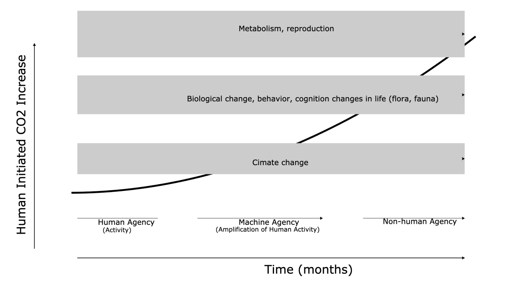

Figure 2. Circularity accounting model

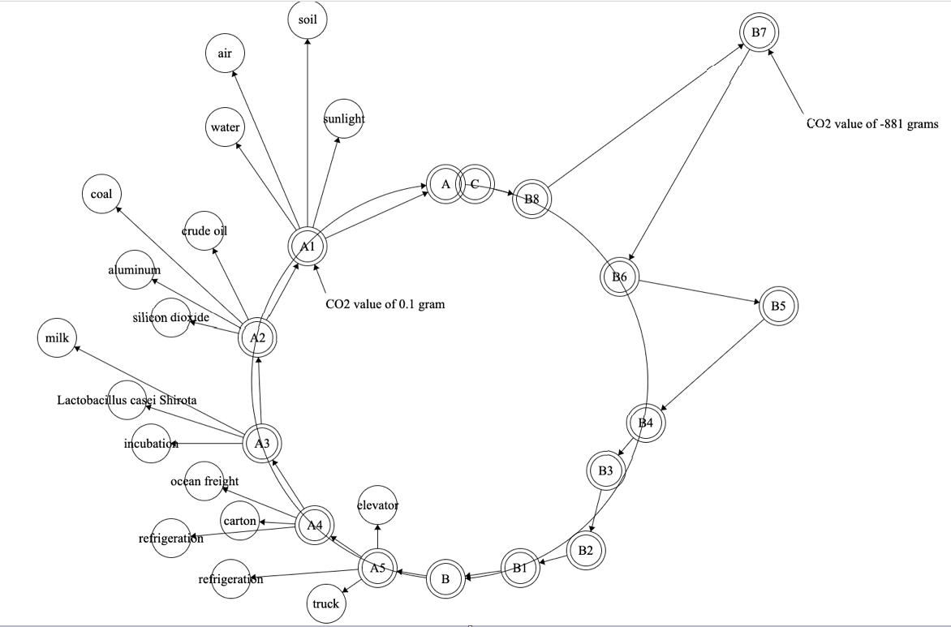
NOTE: S_{chain} is apparent in the variance from circularity.

Figure 3. Example of practical application of CAM
